Walking Navigation App

**USER GUIDE**

VERSION 2.0.0

Christopher, Rishi, Ryan, Yang

TEAM 55

13 May 2018

# 

# Content

|  |  |
| --- | --- |
| *Introduction and Purpose* | *2* |
| *App* *Features* | *2* |
| *Instructions for Use* | *3* |
| *Known Bugs or Limitation**s* | *4* |

# Introduction and Purpose

The Walking Navigation App is the proof-of-concept of a web-app based navigation system that is developed by Team Funny Fliers under GetOverHere Organization. This navigation app is intended to replace the needs of aides accompanying visually-impaired people so that they can walk on their own with just the help of their smartphones.

Through the use of this app, the user will be directed along a pre-determined route one step at a time. The pre-determined route contains an ordered list of coordinates which we believe is the safest and the shortest route. Upon reaching the destination, the user will be notified so that the user know that their trip has finished.

# App Features

The Walking Navigation App is fully equipped with feature that will definitely aid visually impaired people so that they can walk safely. The features that is present in the app are:

* Audio aid

The Walking Navigation app will periodically play an audio track to tell the user whether to go forward, turn right, etc. The audio will be played when the action that the user has to do changes

* Device orientation sensor

This sensor will serve as the app’s compass to determine which way the user has to go next

* GPS tracking

With the GPS tracking, the app can guide the user safely to the destination by constantly

monitoring their location and telling them where to go

* Cross-platform

Since The Walking Navigation App is a web-app, it can be accessed through iOS and Android, and also Windows* devices.

*note that this has only been tested for pc version of windows and not windows phone.

* No update required

This is a feature that only web-apps have which is that no update is ever required for the user because everything is stored in our own server and your app will automatically connect to our server every time you run the app.

# Instructions for Use

1. This is the main page of the app. On his page is shown all the current available pre-recorded paths that we can test. The main page is made to be interactive which means the user interact with each of the listed paths. In this manual, the first path is tapped and it will show the image below.

Figure

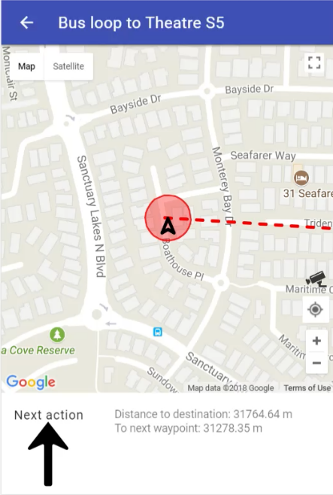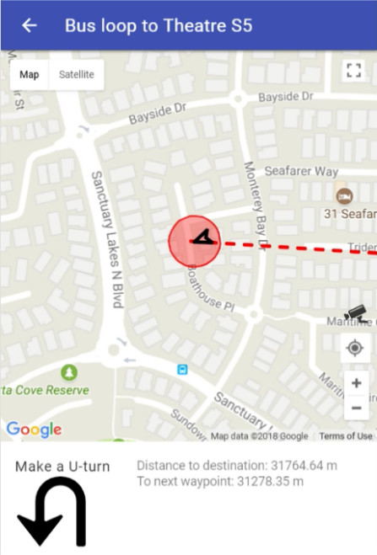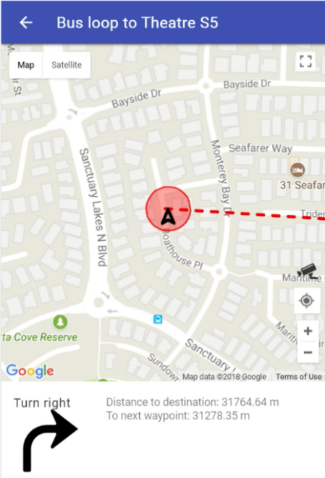

Figure 4

Figure 3

Figure

1. This is the interface of the page in which the navigation is actually happening. The upward pointing arrow on the centre of the map indicates the user’s current position. Across these 3 images, it is shown that the little arrow can also rotate and it indicates which direction the user is currently facing.
2. The big arrow on the bottom left screen shows the next action the user should take. When the app first loads, the arrow will point upwards (as shown in figure 2) and it will change accordingly.
3. The red dashed line shows the path to the next waypoint which the user should follow and the circle indicates the accuracy of the GPS. If it is red, than it is currently not that accurate. If it’s a green, then it’s an OK. As the user moves, the map, marker, and the circle will also be moved to the user’s new position and the map will also be centred on the new position.
4. The auto-pan feature can be toggled on/ off by pressing the camera icon that is located on the right side of the map.

# Known Bugs or Limitations

The app currently as it is, the audio that is played may sometimes stutter and the GPS may also go awry in some cases.

The limitation to this app is that it can’t run without any connection to the internet.